ECE0202: Embedded Systems and Interfacing
Lab 4: Keypad Scanning (in assembly)
Due: TBD

Objectives
- Understand I/O multiplexing technique
- Be familiar with keypad scanning algorithms
- Implement software debouncing
Pre-Lab Reading
- Chapter 14.9 Keypad Scanning
Deliverables – total 100 points
- (40 points) – demonstration of keypad scanning that displays the pressed character on the Tera Term.
- (35 points) – Code submission. Code should use software debouncing and be well-written and commented.
- (25 points) Submission of the pre-lab register tables and post-lab questions. Indicate how each group member participates and contributes to the lab at the end of the lab report.
- Indicate each group member’s Participation and Contribution.

Please submit your code and pre-lab answers and your Circuit photo as a pdf to Black board.

Keyboard Interface

The 4x4 keypad used in this lab requires 8 pins (4 row pins and 4 column pins). In this lab, the connection between the keypad and the discovery kit is shown in the following table.

Row | R1 → PC0 | R2 →PC1 | R3 →PC2 | R4 →PC3
Column | C1 → PB1 | C2 → PB2 | C3 → PB3 | C4 → PB5

All pins of the input port (C1, C2, C3, and C4) need be pulled up to 3.3V with2.2k$Ω$ resistors on breadboard; Within the processor, each GPIO pin can be pulled up via an internal resistor (between 20 and 55k$Ω$), but the internal pull-up current capability is too weak, and therefore an external pull-up resistor is required, as drawn in Fig. 1.

When looking at the front side of the keypad, the pins on the connector from left to right are:
R1 – R2 – R3 – R4 – C1 – C2 – C3 – C4

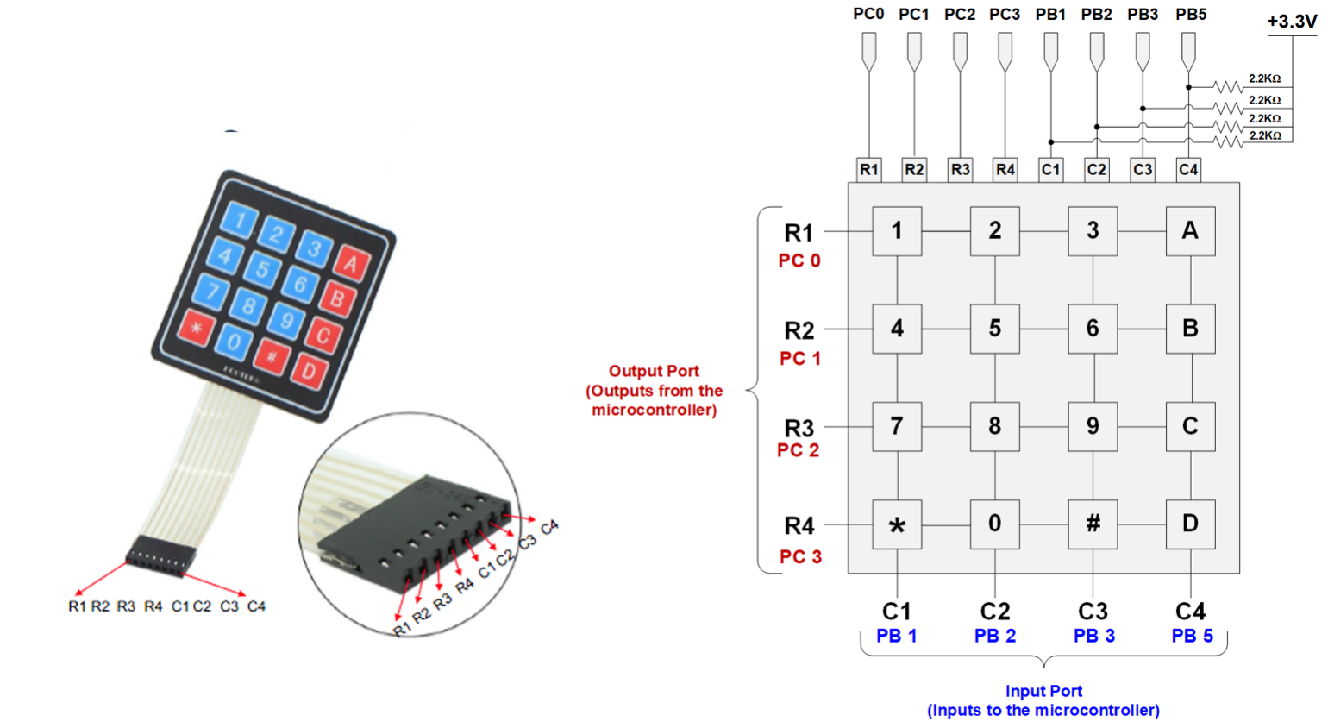
Figure 1- Picture and schematic of the keypad
The maximum current a GPIO pin can source or sink is 20 mA. When calculating the value of external pull-up resistors, make sure that the current does not exceed 20 mA. For example:

$$\frac{3 V}{2.2 kΩ}=1.4 mA$$
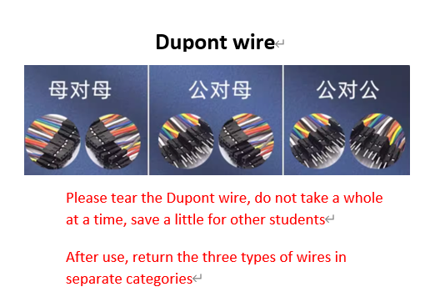
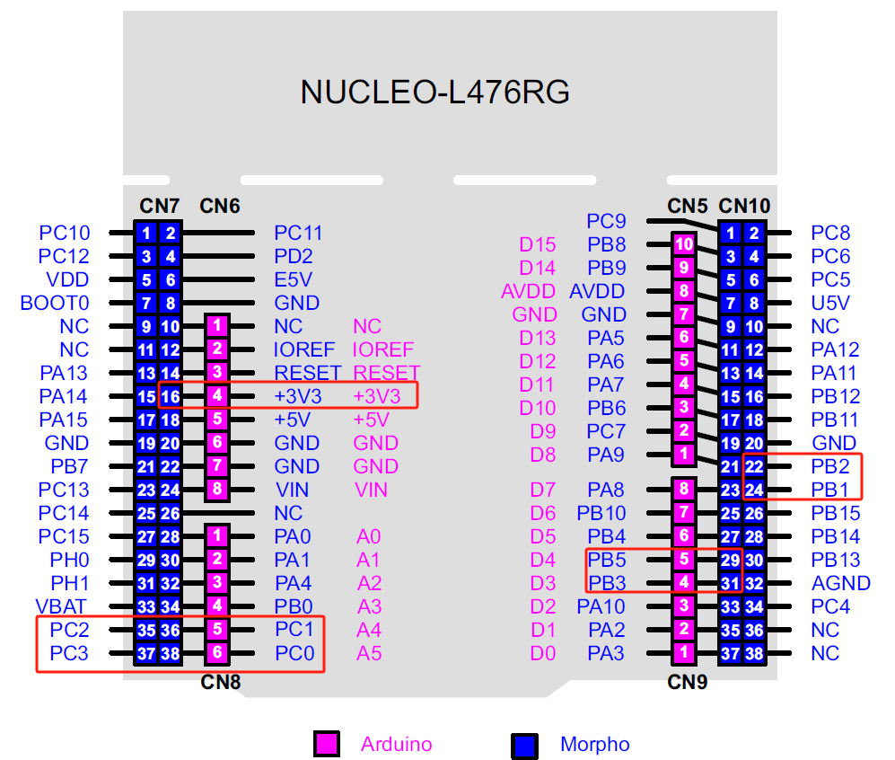
On the Nucleo board, all pins in the input port (PB1, PB2, PB3, and PB5) are connected to ground via a 100 nF capacitor. A very short delay should be added before reading the input port, as seen later in the software flowchart in Fig. 3.
ASCII
In order to write to the Tera Term, you must store the code for an ASCII character into a memory location. In lab 1, the string to be displayed on the Tera Term is stored at a memory location called “str”. This can also be used as the memory location that stores the character you display in this lab.

To display a character on the Tera Term, you must store the associated ASCII code in the memory location “str”, load the memory address of “str” into r0, and then run the instruction BL USART2_Write.
The following table gives ASCII codes for many characters. Note that these are in decimal!
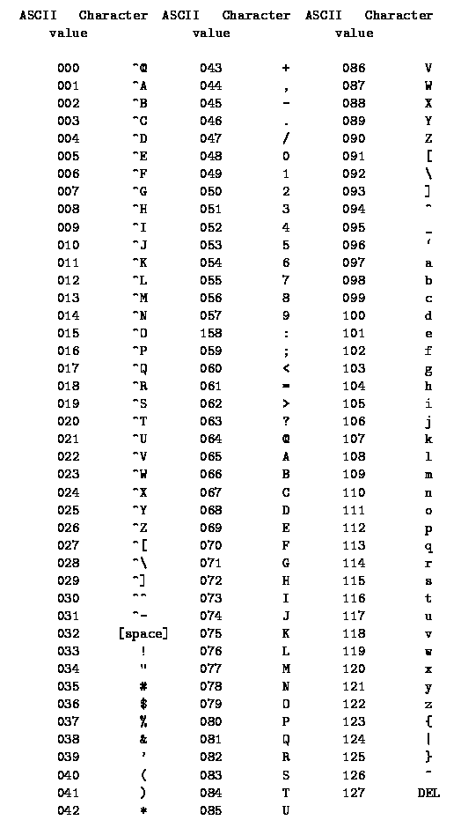
Figure 2 - ASCII character codes. From https://ee.hawaii.edu/~tep/EE160/Book/chap4/subsection2.1.1.1.html

Software Flowchart

The following software flowchart is a modified version of that shown in textbook chapter 14.9, and should be used as a general guide for writing the program used in this lab.

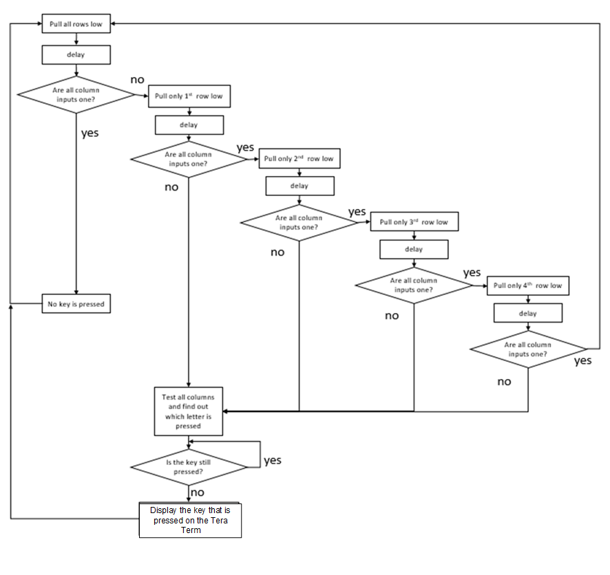
Figure 3 - Software Flowchart for the keypad scanning algorithm

Pre-Lab Register Tables (5 points)

Configure Port C: Pin 0, 1, 2, and 3 as Digital Output
GPIO Mode: Digital Input (00), Digital Output (01), Alternative Function (10), Analog (11)

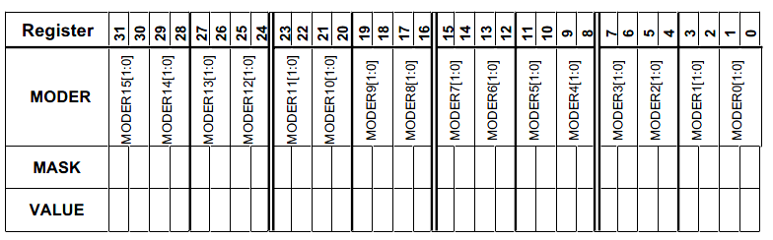

GPIOC Mode Register MASK Value = 0x______________________________________ (in HEX)

GPIOC Mode Register Value = 0x_______________________________________ (in HEX)

Configure Port B: Pin 1, 2, 3, and 5 as Digital Input
GPIO Mode: Digital Input (00), Digital Output (01), Alternative Function (10), Analog (11)



GPIOB Mode Register MASK Value = 0x______________________________________ (in HEX)

GPIOB Mode Register Value = 0x_______________________________________ (in HEX)
Write to Port C: Pins 0, 1, 2, and 3 connect to the rows of the keypad

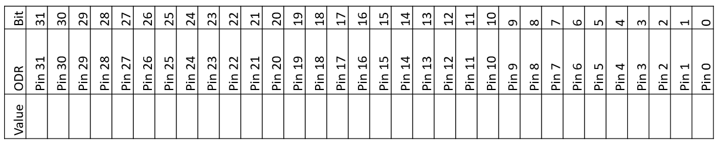

Value written to PORTC ODR in order to pull down all rows:_________________________________(in HEX)

Value written to PORTC ODR in order to pull down row 1:___________________________________(in HEX)

Value written to PORTC ODR in order to pull down row 2:___________________________________(in HEX)

Value written to PORTC ODR in order to pull down row 3:___________________________________(in HEX)

Value written to PORTC ODR in order to pull down row 4:___________________________________(in HEX)

Read from Port B: Pins 1, 2, 3, and 5 connect to the columns of the keypad



Mask to check if a button from column 1 has been pressed:___________________________________(in HEX)

Mask to check if a button from column 2 has been pressed:___________________________________(in HEX)

Mask to check if a button from column 3 has been pressed:___________________________________(in HEX)

Mask to check if a button from column 4 has been pressed:___________________________________(in HEX)

Post-Lab Questions (20 points)

Please include answers to the following questions with your submission of the pre-lab register contents:

- How is software debouncing implemented in your program? (3 points)
- What do we mean when we say that the STM32L4’s internal pull-up resistors are too weak for this application? (5 points)
- When multiple keys are pressed, there could be a short circuit (as shown in the figure). How to configure the output GPIO to avoid this scenario? (7 points)
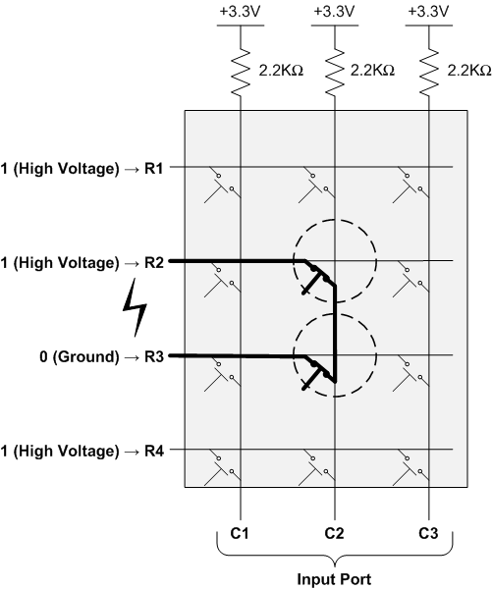
- In the following 2 cases, can the scan algorithm correctly detect all keys pressed? If so, how to modify the flowchart (figure 4) of the scan algorithm. If not, explain the reason. (5 points)

Case1 Case2

Means the keys that are simultaneously pressed.

Participation and Contribution

Please indicate the participation and contribution for each group member using the following table.

Name | Participation and Contribution

